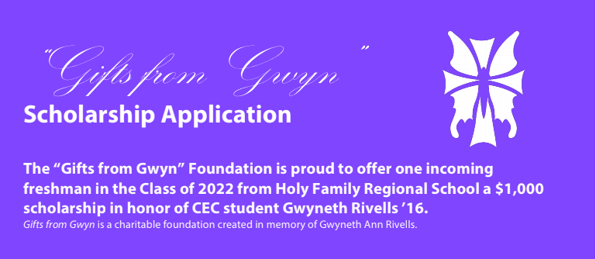

Name ________________________________

Male ___ Female ___

Address ________________________________________________

_______________________________________________________

Home Phone ____________________________________________

Email __________________________________________________

Father/Guardian ______________________________________

Occupation __________________________________________

Father’s Address ______________________________________

Father’s Email ________________________________________

Mother/Guardian ______________________________________

Occupation ___________________________________________

Mother’s Address ______________________________________

Mother’s Email ________________________________________

**“Gifts from Gwyn” Scholarship Guidelines**

**Eligibility**

Open to all current students in grades 9-12 at CEC (2023, 2024, 2025, 2026).

Student must be in good academic and disciplinary standing.

**Criteria**

Students may submit an art piece inspired by the theme “Friendship” or “Random Acts of Kindness”

Pieces may be submitted in the form of a poem, drawing, video, or song

**Value**

The award is a $1,000.00 one-year scholarship that is applied directly to tuition.

**Selection**

Selection of the scholarship award will be determined by the Rivells family and any members of a committee chosen by them

**Deadline**

*All applications must be submitted to Conwell-Egan Catholic High School by December 16, 2022*

**How to Submit**

*Applications may be submitted in the Admissions Office or via email at krice@conwell-egan.org*

***Acceptable Formats: USB drive, CD/DVD-ROM, Portfolio, JPG, PDF, .MOV, .MP4, .AVI, .WMV***